(Approx. 843 words)

Posters with Canva
By Caden and Nathan Kang, Los Angeles Computer Society
North Hollywood High School Students
www.lacspc.org
leahjc (at) sbcglobal.net

Nowadays, many flyers and posters are created and shared online. Canva is an online program that allows you to create posters, flyers, videos, cards, and even social media posts and share them with other people in your community. It also allows multiple people to work on the same document, so a group of people can all collaborate on the project at the same time.

Getting started
To create an account on Canva, click on the “Sign Up” button on the main page. Afterward, you can choose to either connect Canva with your Google or Facebook account or sign up with your email.
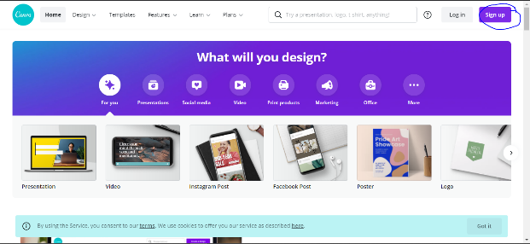

Choosing a design
There are many designs available on Canva to choose from, which could confuse first-time users. However, in this article, we will be focusing on the poster design. This is because many other designs and templates are almost identical to the poster except for the size.

Creating a poster
To start, click on “Create a Design” in the top right corner after signing in. Then, click “Poster.” If it does not appear on the “Suggested” menu, you can manually type it into the search bar. From there, you should be directed to a page similar to the one here:
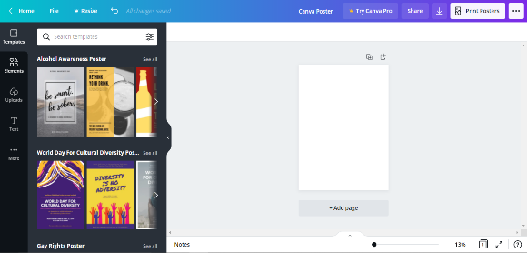
1.
2.
4.
3.
5.
6.
7.
8.
9.
10.
- The name of your poster: Initially, it will be “Untitled,” but you can change the name by clicking on it and then entering the name you wish the poster to be called.
- Templates: Canva has several pre-made templates for various posters, such as advertisements, lost dog, and COVID-19 awareness posters. Click on the template you desire, and it will be displayed on the screen as your poster.
- Elements: These are lines, shapes, photos, videos, and audio that Canva provides. If you purchase Canva Pro, you will have access to more of these elements. To add an element to your poster, drag and drop the element you wish to include to the one you created.
- Uploads: This function allows you to upload your own images, video, and audio to your poster if you don’t like the provided options or if you want to personalize your poster more. After clicking on the button, select whether you wish to upload an image, video, or audio and then click “Upload Media.” Next, choose whether to upload from your device, Facebook, Google Drive, Instagram, or Dropbox. Then, click on the file. It will appear on the menu, and you can just drag and drop the files onto the poster.
- Text: This button allows you to drag a textbox onto the poster. There are many different fonts available, and Canva Pro will unlock even more fonts to use.
- More: Clicking on this button will allow you to use content from other apps like Facebook and even Google Maps. You can also create a QR Code that will direct people to a URL they can scan with their phone’s camera.
- This is the menu. You can drag and drop items from the menu onto the poster to add them. To close the menu, simply click on the arrow facing left. To reopen the menu, click on any of the buttons on the far left (such as Template, Elements, etc.).
- This is your poster, which is what will be seen by others when you share it with them. You can drag and drop items from the menu onto the poster.
- These two buttons are to add more pages to your poster. The first one on the left will duplicate the current page, while the one on the right will simply add another page. You can also add another page using the “+ Add Page” below the poster.
- This is to zoom in or out of the poster to make it larger or smaller or see it as a whole.

Sharing Posters
One of the great things about Canva is that you can share your poster with other people and even work on the same poster together at the same time. After you have created your poster, simply click on the Share button towards the top right corner. When you click on the Share button, a menu like this appears:
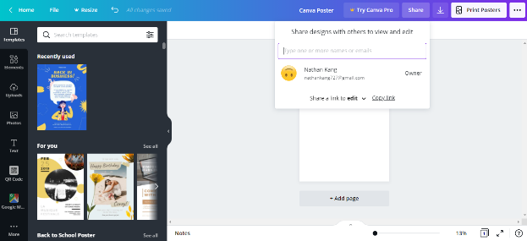
You can type in the email addresses of people you want to add to the Canva poster and change whether you want them to edit, use your poster as a template, or only view it. Afterward, they will be sent an email through which they can open your poster. Keep in mind that the people that you add must also have Canva accounts.

You can also add them to be a part of your team. Any designs that the team has collaborated on will be available to every member.

These are just the basics for creating your own poster on the Canva platform! Its ability to allow multiple people to work on a document at a time is quite practical. It is a perfect opportunity for you to create stunning projects with others.

